Heart Disease Prediction Using Bio Inspired Algorithms

In this project student want to detect heart disease from dataset using Bio Inspired 4 features optimizing algorithms such as Genetic Algorithm, Bat, Bee and ACO. Here ACO algorithm is design in python to solve Travelling Salesman Problem to find shortest path and it cannot be implemented with heart disease dataset, so I am implementing 3 algorithms called Genetic, Bat and Bee.

Bio inspired algorithms design to optimized features used in dataset for training classification algorithms to increase prediction accuracy, sometime some datasets may have irrelevant values inside dataset and those irrelevant attributes or values may degrade classification accuracy so using optimize algorithms we can reduce features (attribute values) from dataset. This optimize algorithms will be applied on dataset to check whether all values are related to dataset or not, if any attribute found unrelated then it will removed from dataset.

To implement this algorithms I am using Heart disease dataset which contains 14 attributes and 4 class labels where 0 refers to No heart Disease and 1 refers to stage1 disease and 2 and 3 refers stage 3 and 4 disease.

Below are some values from dataset to train algorithms

age,sex,cp,trestbps,chol,fbs,restecg,thalach,exang,oldpeak,slope,ca,thal,class

63.0,1.0,1.0,145.0,233.0,1.0,2.0,150.0,0.0,2.3,3.0,0.0,6.0,0

67.0,1.0,4.0,160.0,286.0,0.0,2.0,108.0,1.0,1.5,2.0,3.0,3.0,2

67.0,1.0,4.0,120.0,229.0,0.0,2.0,129.0,1.0,2.6,2.0,2.0,7.0,1

37.0,1.0,3.0,130.0,250.0,0.0,0.0,187.0,0.0,3.5,3.0,0.0,3.0,0

First records contains dataset column names and remaining records are the values of dataset. In last column we have class values as 0, 2, 1 and 3 as disease stage.

Test dataset also contains record values but it will not have class labels and application will apply that test values on train dataset to predict it class labels. Some values from test dataset.

age,sex,cp,trestbps,chol,fbs,restecg,thalach,exang,oldpeak,slope,ca,thal

63.0,1.0,1.0,145.0,233.0,1.0,2.0,150.0,0.0,2.3,3.0,0.0,6.0

67.0,1.0,4.0,160.0,286.0,0.0,2.0,108.0,1.0,1.5,2.0,3.0,3.0

67.0,1.0,4.0,120.0,229.0,0.0,2.0,129.0,1.0,2.6,2.0,2.0,7.0

In above test dataset we can see there is no class name and application will predict it. All this files are available inside ‘heart_dataset’ folder.

In that ‘heart_dataset’ folder I kept dataset URL and information of dataset for references.

Screen shots

To run this project double click on ‘run.bat’ file to get below screen

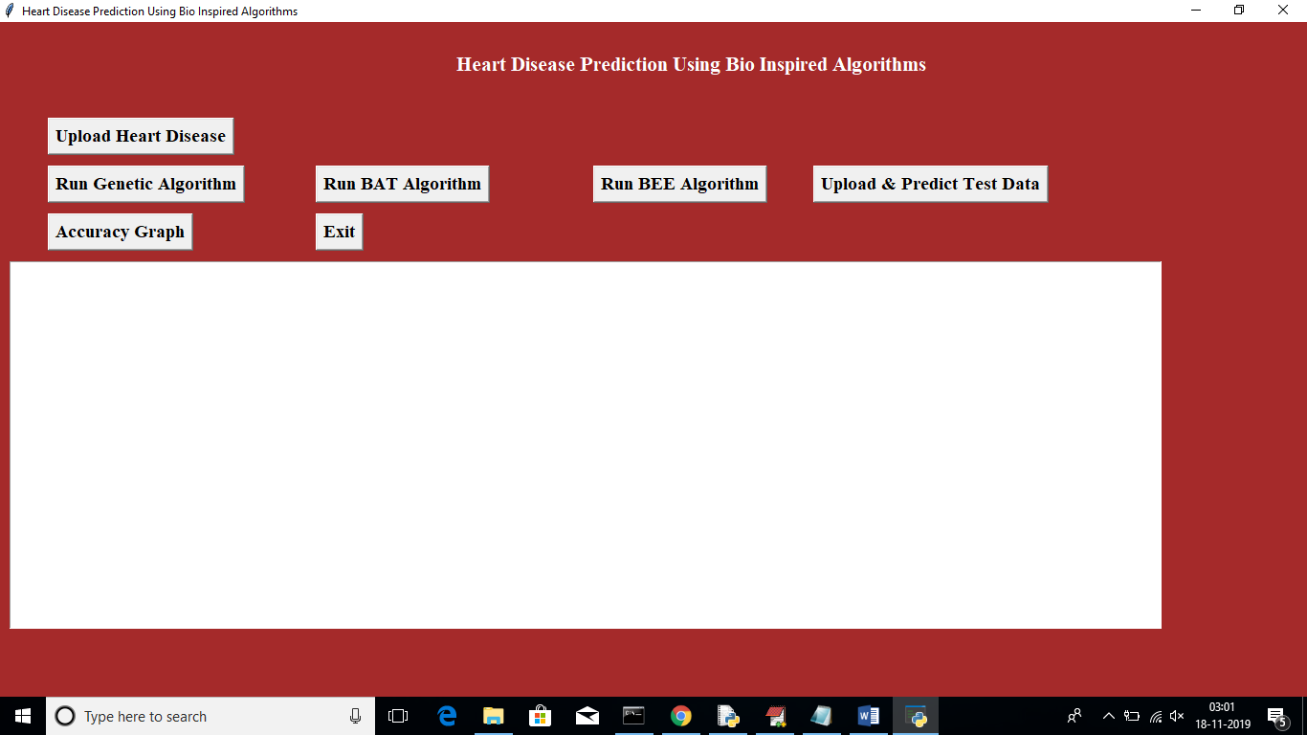

In above screen click on ‘Upload Heart Disease’ button and upload heart disease dataset. See below screen

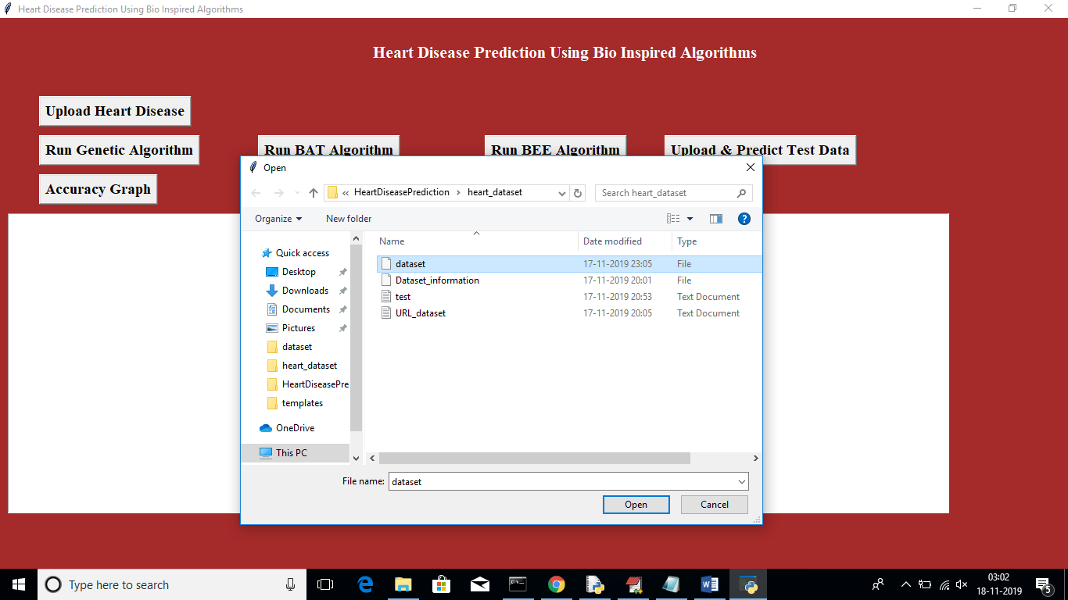

In above screen uploading dataset file, after uploading will get below screen

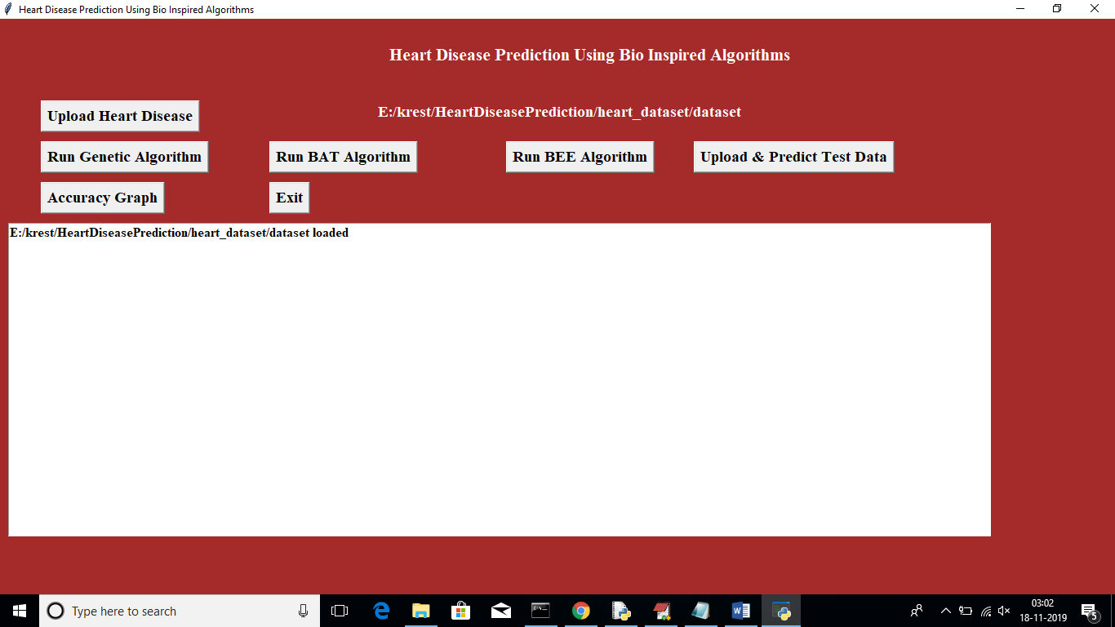

Now click on ‘Run Genetic Algorithm’ button to run genetic algorithm on dataset and to get its accuracy details. While running this algorithm u can see black console to see feature selection process, while running it will open empty windows, u just close all those empty windows except current window

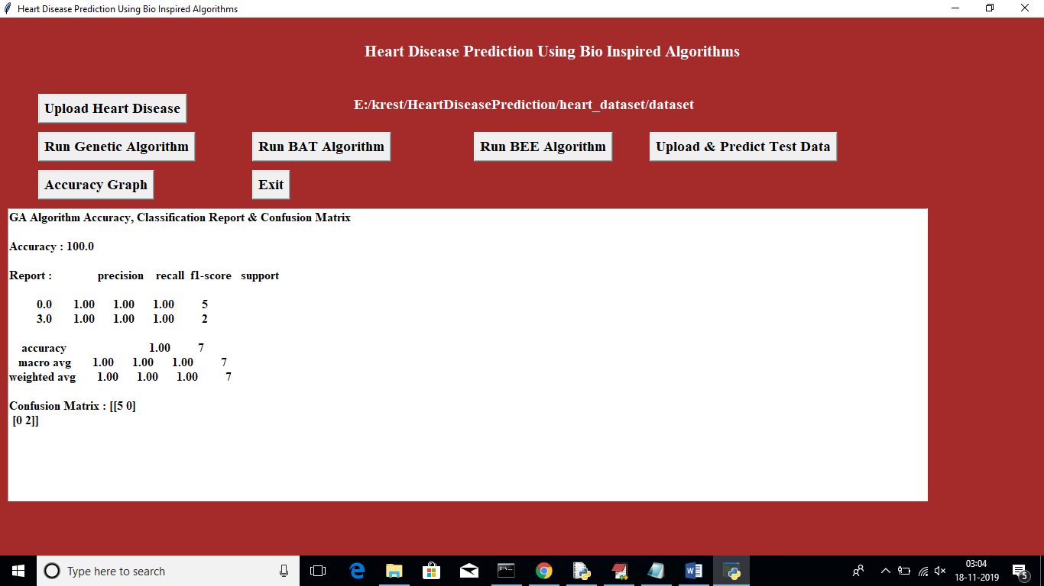

In above screen for GA accuracy, precision and recall we got 100% result. Now click on ‘Run Bat’ algorithm button to get its accuracy

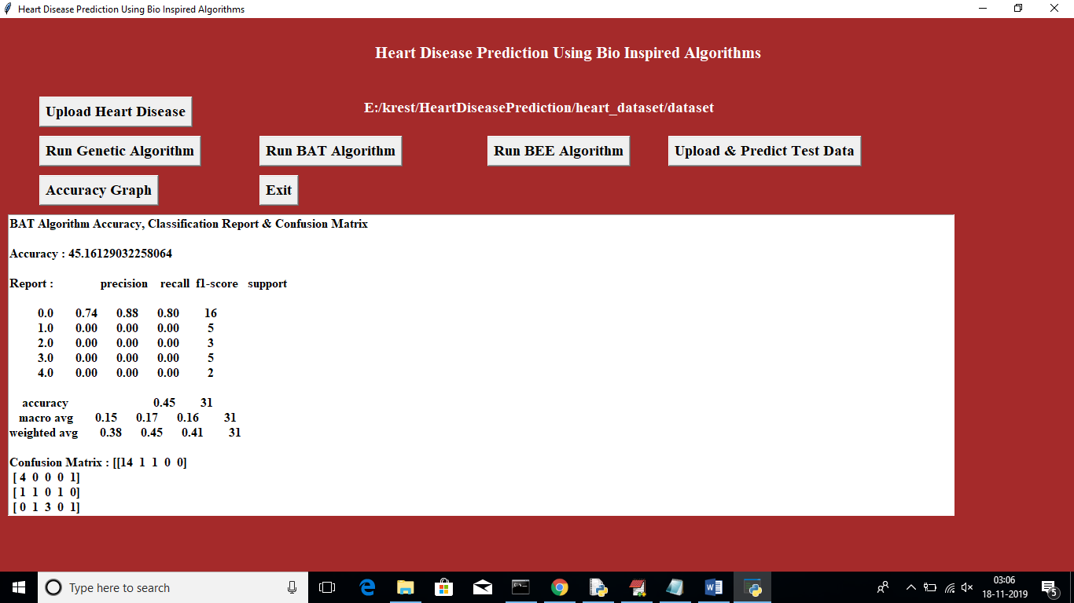

In above screen for BAT we got 45% accuracy, now click on ‘Run BEE Algorithm’ button to get BEE accuracy

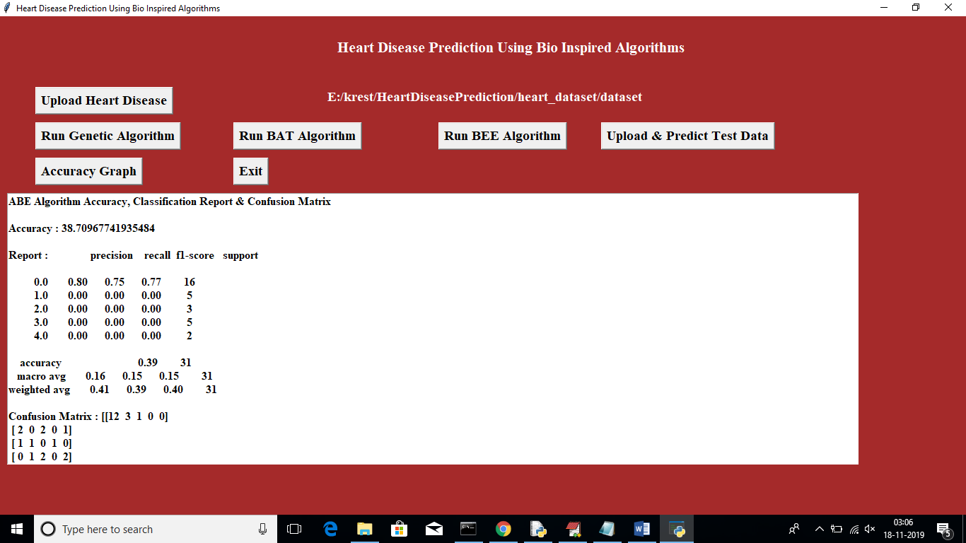

In above screen for BEE we got 38% accuracy, now click on ‘Upload & Predict Test Data’ button to upload test data and to predict it class

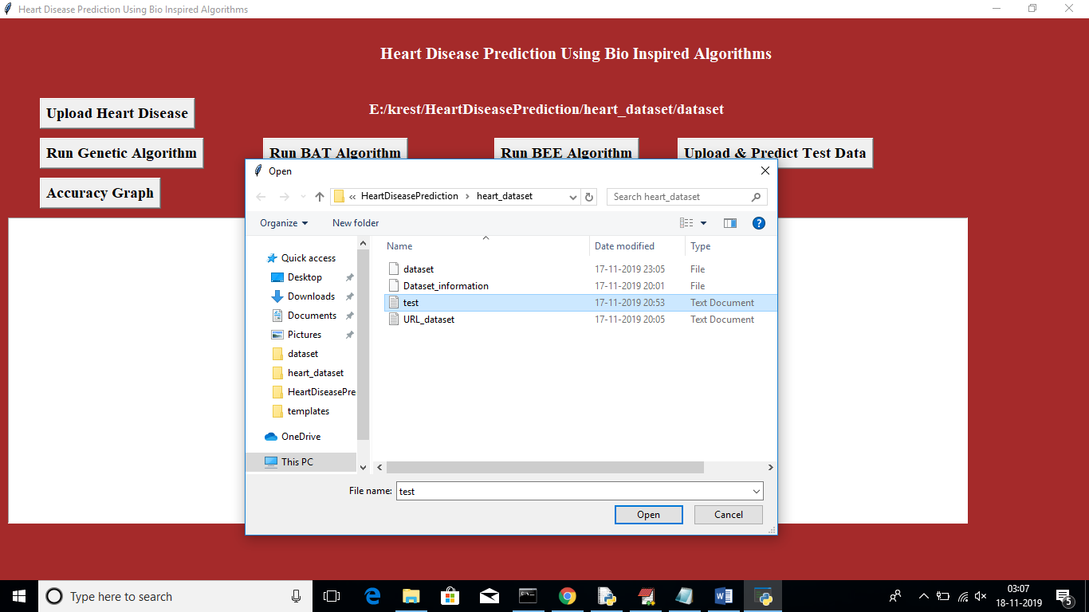

In above screen I am uploading test file which contains test data without class label, after uploading test data will get below screen

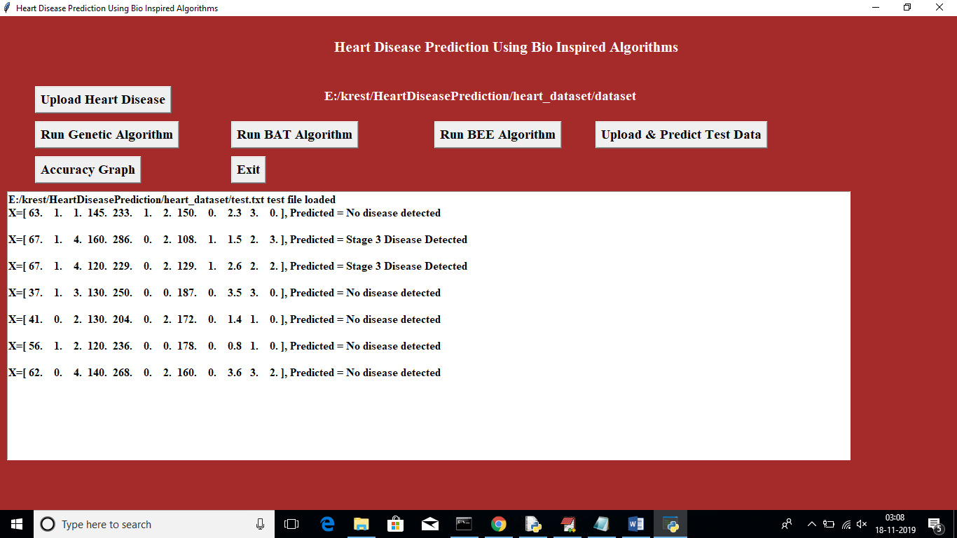

In above screen application has predicted disease stages. Now click on ‘Accuracy Graph’ button to view accuracy of all algorithms in graph format

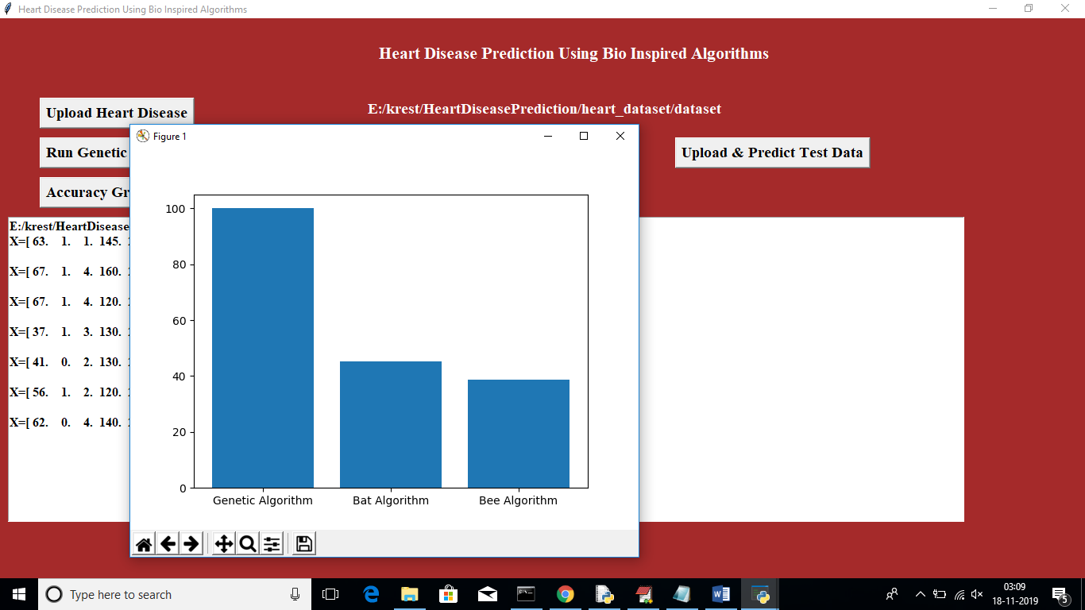

In above graph x-axis represents Algorithm Name and y-axis represents accuracy of those algorithms